

**Tribhuvan University**

**Faculty of Humanities and Social Science**

**Hotel Management System**

**A PROJECT REPORT**

Submitted to

Department of Computer Application

Padmashree International College

***In partial fulfillment of the requirements for the Bachelors in Computer Applicatio******n***

**Submitted by**

Manish Pathak

Symbol No.: 6220760

Reg. No.: 6-2-622-32-2018

Under the Supervision of

**Basanta Chapagain**



**Tribhuvan University**

**Faculty of Humanities and Social Sciences**

**Padmashree International College**

# SUPERVISOR’S RECOMMENDATION

I hereby recommend that this project prepared under my supervision by Manish Pathak entitled “Hotel Management System” in partial fulfillment of the requirements for the degree of Bachelor of Computer Application is recommended for the final evaluation.

………………….

SUPERVISOR

Basanta Chapagain

Project supervisor

Bachelor of Computer Application

Padmashree College, Tinkune



**Tribhuvan University**

**Faculty of Humanities and Social Sciences**

**Padmashree International College**

# LETTER OF APPROVAL

This is to certify that this project prepared by Manish Pathak and entitled “Hotel Management System” in partial fulfillment of the requirements for the degree of Bachelor in Computer Application has been evaluated. In our opinion, it is satisfactory in the scope and quality of a project for the required degree.

|  |  |
| --- | --- |
| **…………………….**  **Basanta Chapagain**  **Project supervisor**  **Bachelor of Computer Application** | **…………………….**  **Raj Kumar Koirala**  **Coordinator**  **Bachelor of Computer Application** |
| **…………………….**  **SIGNATURE of External Examiner**  **External Examiner** |  |

# ABSTRACT

In my project “Hotel Management System” I have tried to show how the data/information in hotels is managed. This is just an overview of management in hotels. It manages and maintains the records of guests, rooms, employees, and drivers in the hotel. The project is aimed to maintain the day-to-day state of admission/vacation of Residents, List of employees, room details, etc. The system will help the hotel staff to perform the day-to-day work of the hotel through the software instead of written in hardcopy. The main objective of this project is to provide a solution for a hotel to manage most of their work using a computerized process.

This project is designed to create a platform that allows Hotel Staff to keep track of transactions like room reservations, room booking, financial administration of the hotel, staff record keeping, and other day-to-day activities involved in the running and management of a hotel. The implementation is based on the requirements for a hotel management system. The project work is divided into five major categories which are; Front Desk, Accommodation, Finance & Account, Personnel Staff Record (Human resource management), Driver Record Management, etc.

The project was designed with the use of Intellij IDEA which is an integrated development environment made by JetBeans. It can be used to develop graphical user interface applications. The database system was created using a Microsoft SQL server (MSSQL).

**Keywords**: - guest, staff, driver, room allocation, payment, managing information.

# ACKNOWLEDGEMENT

First and foremost, we offer our sincere appreciation for the learning opportunities provided by Padmashree College.

We cannot express enough thanks to our program coordinator Mr. Rajkumar Koirala for providing his continued support and encouragement.

Our completion of this project could not have been accomplished without the support of our project supervisor Mr. Basanta Chapagain, who guided us in doing these projects. He provided us with invaluable advice and helped us in difficult periods. His motivation and help contributed tremendously to the successful completion of the project.

Also, we would like to thank my family and classmates for their support. Without that support, we couldn’t have succeeded in completing this project.

In the end, we would also like to thank Tribhuvan University for giving us this opportunity via the course of Computer Application to help us understand the project ethics at this early stage and helped us to evaluate my knowledge and expand it a little more.

Our heartfelt thanks.

Sincerely

Manish Pathak

**Table of Contents**

SUPERVISOR’S RECOMMENDATION i

LETTER OF APPROVAL ii

ABSTRACT iii

ACKNOWLEDGEMENT iv

LIST OF ABBREVIATIONS ix

Chapter 1 INTRODUCTION 1

1.1 Introduction 1

Problem of Statement 1

1.3 Objective 2

1.4 Scope and limitation 2

1.4.1 Scope 2

1.4.2 Limitation 3

1.5 Development Methodology 3

1.6 Report Organization 3

Chapter 2 BACKGROUND STUDY AND LITERATURE REVIEW 4

2.1 Background Study 4

2.2 Literature Review 4

Chapter 3 SYSTEM ANALYSIS AND DESIGN 6

3.1 System analysis 6

3.1.1 Requirement analysis: 7

3.1.2 Feasibility Study 10

3.1.3 Data modeling ER-Diagram 11

3.1.4 Process Modeling (DFD) 13

3.2. System Design 14

3.2.1. Architectural Design 15

3.2.2 System Flowchart 16

3.2.3. Database Schema Design 17

3.2.4. Interface Design (UI Interface / Interface Structure Diagrams) 18

3.2.5. Physical DFD 21

3.3 Algorithm details 21

Chapter 4 IMPLEMENTATION AND TESTING 24

4.1. Implementation 24

4.1.1. Tools Used (CASE tools, Programming language, Database platforms) 24

4.1.2. Implementation details of modules 24

4.2 Testing 25

4.2.1 Test Cases for Unit Testing 26

Chapter 5 CONCLUSION AND FUTURE RECOMMENDATIONS 32

5.1. Lesson Learnt / Outcome 32

5.2 Conclusion 32

5.3 Future Recommendations 33

REFERENCES 33

APENDICES 34

**LIST OF FIGURES**

Figure 3‑1Waterfall Model for Hotel Management System 6

Figure 3‑2 Process flow diagram of Hotel Management System 8

Figure 3‑3 Use Case Diagram 9

Figure 3‑4 Gantt chart 11

Figure 3‑5 ER-Diagram of Hotel Management System 12

Figure 3‑6Level 0 DFD for Hotel Mangement System 13

Figure 3‑7 Level 1 DFD for Hotel Management System 14

Figure 3‑8 Architectural design 16

Figure 3‑9 Flow chart of Hotel Management System 17

Figure 3‑10 Database Schema design for Hotel Management System 18

Figure 3‑11Physical DFD of Hotel Management System 21

**LIST OF TABLE**

Table 3‑1: Admin Requirement 7

Table 3‑2 Staff requirement 7

Table 4‑1 A test case for admin login in HMS. 26

Table 4‑2 A test case for Add room HMS. 26

Table 4‑3 A test case for Add room HMS. 27

Table 4‑4 A test case for Add Employee in HMS. 28

Table 4‑5 A test case for Add Driver in HMS. 29

Table 4‑6 A test case for Staff login in HMS. 30

Table 4‑7 A test case for Add Guest in HMS. 30

# LIST OF ABBREVIATIONS

**API** Application Programming Interface

**CRUD** Create, Read, Update and Delete

**DFD** Data Flow Diagram

**ERD** Entity Relationship Diagram

**HMS** Hotel Management System

**JVM** Java Virtual Machine

**MYSQL** My Structural Query Language-

**UI** User Interface

# 

# INTRODUCTION

## **Introduction**

The Hotel management system is a system that aids the management of the Customers’ data, Hotel staff data, customers’ registration, Customer accommodation or allocation into specific rooms, room reservation, and Personnel staff management.

This application is just an overview of management in hotels. It manages and maintains the records of customers, rooms, employees, and drivers in the hotel. The application is aimed to maintain the day-to-day state of admission/vacation of Residents, List of employees, room details, etc. The main objective of this application is to provide a solution for hotels to manage most of their work using computerized processes.

This software application will help the admin to handle the addition of staff, room, driver, etc. Similarly, it also helps front-desk staff to handle room allocation, guest information management, and payment details.

The rooms have different categories like single beds, double beds, etc. so their charges and records will be maintained accordingly. Similarly, the driver has different time shifts like morning day, and night, so their records will be maintained accordingly.

The project, Hotel Management System is a desktop-based application that allows the hotel staff to handle all hotel activities online. Interactive GUI and the ability to manage various rooms, employees, drivers, and customers make this system very flexible and convenient. This application gives managers the power and flexibility to manage the entire system from a single online system. The hotel management project provides room booking, staff management, and other necessary hotel management features. The system allows the manager to post available rooms in the system.

## **Problem of Statement**

As the growing trend in most businesses in the InfoTech World of Computers, the need for accuracy, perfectness, speed, and high memory data storage is a must. Every problem must be solved with the least amount of time and energy.

The problems faced by the existing system and hope to be solved by the Hotel Management System are described below:

Difficulty in the maintenance of records because of using traditional recording technique

Time-consuming

Editing data becomes a tedious job

No security of data

Mistakes occurring in the Calculation of funds

Lack of efficiency

Data redundancy

Data inconsistency

Incidence of Fraud

## **1.3 Objective**

The proposed system aims to provide solutions to the problems stated above and help the user to manage the hotel effectively and efficiently through:

Hotel Room Bookings and Reservation

Front Desk Operations

Managing Guest Profile

User Privilege and security control

Keeping a tab on guest check-in check-out status

Maintenance of hotel rooms.

Providing a user-friendly interface.

## **1.4 Scope and limitation**

### 1.4.1 Scope

The study is focused on the critical operations carried out within the hotel administrative system. These major operations include

Front-desk operations (customer management, room allocation, cashier posting)

Accommodation (Hotel room management, staff schedules).

Staff record Management.

Accounts Receivable &Payable.

### 1.4.2 Limitation

The limitation of this system is that server has to be on at all times. If the server fails to serve the service then the data cannot be read and written on the database. Not only that the staff needs to take training to work on this software smoothly.

## **1.5 Development Methodology**

For the development of this system, we use the waterfall model. This system is designed with a series of processes starting with requirement analysis, design, implementation, testing, and maintenance which are the different phases of the waterfall model.

## **1.6 Report Organization**

**Introduction**

This chapter deals with the introduction of the system with its objectives and limitations along with the reason why the system is made

**Background Study and Literature Reviews**

This chapter includes information on the current status of the system. And as per the research done about similar types of systems and its finding are also mentioned here

**System Analysis and Design**

This chapter focuses on the different requirements of the system, which describes the functional, non-functional, feasibility analysis Entity Relational diagram, Data Flow Diagram, design of the system with system architecture, database schema, and interface design. and the implementations of the Algorithm with its details

**Implementation and Testing**

This chapter emphasizes tools used in system development, implementation details, and the result of the test performed.

**Conclusion and Future Recommendation**

This chapter highlights the summary of the lesson learned, the outcome, and the conclusion of the whole project and explains what has been done and what further improvements could be done.

# 

# BACKGROUND STUDY AND LITERATURE REVIEW

## **2.1 Background Study**

The hotel management system is the best software for that hotel where lots of information related to the customer staff, and payment should be managed. This software removed the traditional filling system and also improve data security.

Before getting into the development of the project we tried to understand the basic available resources and current practice. It helped us very much in planning the road map for the development.

Currently, few hotels implement similar types of software. We are going to design this system after analyzing the pre-existing software and also include a few more feature that is not included in that software.

## **2.2 Literature Review**

A literature review is an account of what has been done before on a topic by accredited scholars and researchers. The purpose of the literature review is to convey to the reader what knowledge and ideas have been established on the topic, and what their strengths and weaknesses are.

Reviewing the literature is to develop some expertise in one’s area, to see what new contributions can be made, and to receive some ideas for developing a research design. Further, reviewing the literature facilitates the researcher to explore what research studies have been conducted in one’s chosen field of study and what remains to be done. (Wolff and Pant 1999)

Many similar applications have been developed or are in the developing process available on the web where some are free and many need to be procured. Similar applications are found in the Microsoft store and some are third parties applications or systems also. Some of them are:-

eZee

eZee has a wide range of best-in-class hospitality software. Our solutions and services are recognized across the world and recommended by various types and sizes of hotels and restaurants. Our products are accepted globally, owing to the regional compliances and statutory requirements met over the years.

We aim at developing top-rated products to provide the best user experience and streamline your operations. All our product enhancements and upgrades are done keeping your experience in mind. Besides, they’re extremely easy to use; needing no technical knowledge to operate. [1]

HotelsCombined

At HotelsCombined, we know that booking accommodation online isn't easy, but we believe it should be. Having to trawl through a hundred websites looking at a thousand 'deals' can be overwhelming and complicated. At the end of the day, you just want to know you've booked the hotel that's right for you - at the best possible price. We saw the opportunity to do something about this. Since then we've been working hard to find you the best hotel deals.

Our technology cuts through availability and prices from all the top travel websites from around the world, including Booking.com, Expedia, Hotels.com, Agoda, AccorHotels, Hilton , [and many more](https://www.hotelscombined.com/providers). In one quick and easy search, we show you only the information you want to know and need to know. You'll find just what you're after and can be sure you got the most out of your booking [2]

# 

# SYSTEM ANALYSIS AND DESIGN

## **3.1 System analysis**

This system is basically for that hotel where a file base system is used to keep the record. It doesn’t mean that file base recording is bad but some of the problems like human error during data entry, data missing, difficulty to update, and many more. Among them, data security is the major problem of file base Systems so to replace this file base system hotel management system is best. The front desk staff simply log in to the system and keep start recording .they can also provide the services like room allocation according to the customer, providing the driver to the customer to pick and drop to their destination, and a lot more other things from this system. This is the basic feature this system has. Shortly the hotel needs to add any specification to the system then we are also working on that things. [3]

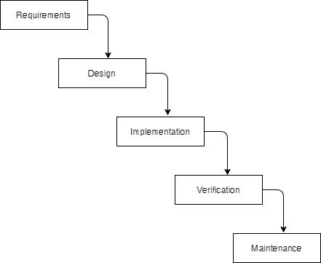

**Figure 0‑1Waterfall Model for Hotel Management System**

### 3.1.1 Requirement analysis:

As per the interview and studies we have discovered the following requirements:

#### **Functional requirement:**

**Table 0‑1: Admin Requirement**

|  |  |
| --- | --- |
| Admin requirement | |
| S.no. | Requirement |
| AR1 | Admin should be able to log in to the database |
| AR2 | Admin can add Staff and store them in the database so they can access to use software |
| AR3 | Admin can Add room and store it in the database |
| AR4 | Admin can Add Driver information and store it in the database |
| AR5 | Admin can add remove or alter the information of staff, driver, and room. |

**Table 0‑2 Staff requirement**

|  |  |
| --- | --- |
| Staff Requirement | |
| S.no. | Requirement |
| SR1 | Staff should be able to log in to the system. |
| SR2 | Staff can add the customer’s detail and store the detail in the database. |
| SR3 | Staff Allocate the room |
| SR4 | Staff can contact the driver whenever required |
| SR5 | Staff can complete the payment through the system. |

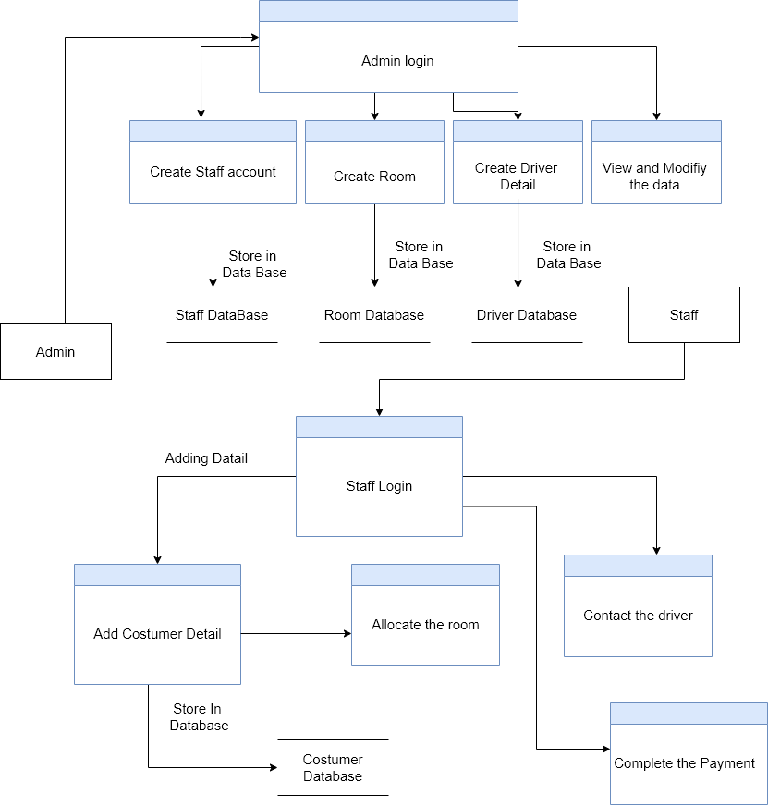

**Figure 0‑2 Process flow diagram of Hotel Management System**

**USE CASE DIAGRAM**

In the Hotel Management system, there are two actors such as admin and front desk staff where

Both admin and the front desk staff are allowed to log in to the system. Admin is allowed to add a room and create employee id and driver’s id. Admin can also view the detail of room employees and drivers whenever required.

Likewise, front desk staff is allowed to add guests and allocate room for the customer. They can also view the customer detail and view the driver details to contact them.

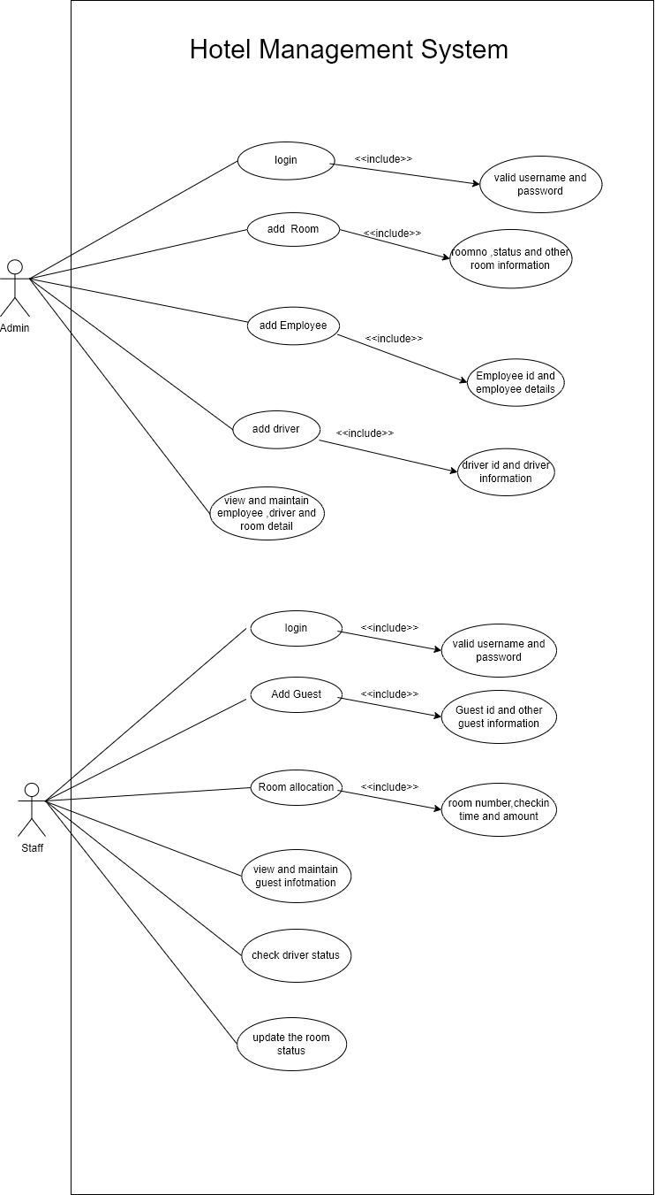

**Figure 0‑3 Use Case Diagram**

#### **Non-functional requirement:**

**User Friendly:**

User Friendly is self-explanatory. When something is user-friendly then it is easy to access and work with it.

Hotel Management System is user-friendly. People having basic knowledge and skills of computers can also easily use this application.

**Simple and easy to use:**

The Hotel Management system uses a simple design as well as simple language on the content to improve the user-friendliness of the desktop application. The Hotel Management system is a desktop application. It can be accessed if the user has access to the system.

## **3.1.2 Feasibility Study**

To analyze whether the software will meet organizational requirements Feasibility is defined as the practical extent to which a project can be performed successfully. To evaluate the feasibility, a feasibility study is performed.

To determine whether the software can be implemented using the current technology and within the specified budget and schedule, A feasibility study is a preliminary investigation of a proposed system to decide whether the system can run smoothly within the organization.

To determine whether the software can be integrated with other existing software. Benefits that are expected and to decide will the organization go for it.

1. **Technical feasibility**

We run studies to figure out if the organization has all the necessary technical infrastructure required for running the new system. As per our study, we found out they have an assembled desktop with Intel i7 3rd gen processor, 4 GB RAM, and 1 TB hard drive. They also had a Dell Inspiron 15, 5000 series laptop with an i7 8th generation processor, 8 GB RAM, and a 1 TB hard drive. They have a good internet connection and source of electricity which can run our system smoothly. Therefore, we planned to use the desktop as the server

1. **Operational feasibility**

During this study, we tried to find out if they had the required manpower to operate the new system. From our study, we found out that they have appointed a staff to look after this new system. He already had a basic knowledge of computers, email, and the internet. Therefore with the user manual and short demonstration he should be able to run the system as intended

1. **Economic feasibility**

We tried to find out if this new system is cost-effective or not for the organization. As this system is a one-time cost for a long-term project. Therefore we found the new system is cost-effective compared to the old approach which can also lead to data loss and wrong records. We also completed our work on the agreed price with a yearly maintenance cost.

1. **Schedule feasibility**

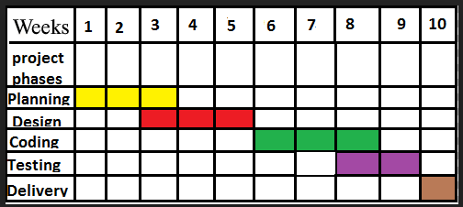This is one of the most important feasibility analyses as it helps an organization estimate how much time the organization will take to complete the project and how much of it is on track to a given schedule

**Figure 0‑4 Gantt chart**

### 3.1.3 Data modeling ER-Diagram

A data model is a mechanism that provides this abstraction for the database application. Data modeling is used for representing entities and their relationship in the database. E-R (Entity Relationship) Model can be referred to as a Data Model. E-R Model is a popular high-level conceptual data model. This model and its variations are frequently used for the conceptual design of database applications and many database design tools employ its concept.

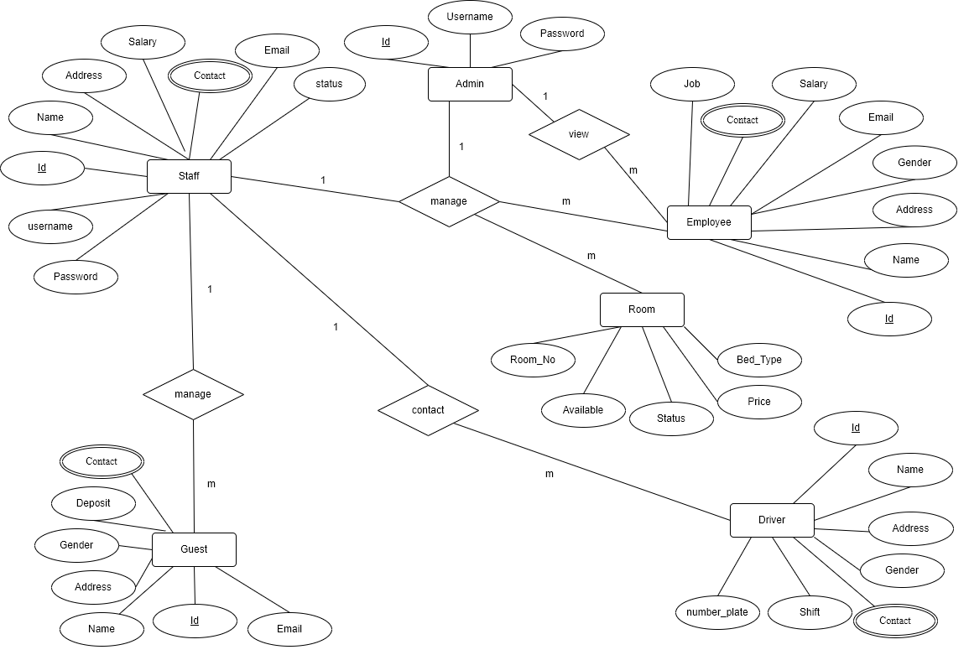

**Figure 0‑5 ER-Diagram of Hotel Management System**

In the above ER diagram, we have six entities Staff, Admin, Employee, Room, Driver, and guest. The staff has attributes like id, Name, Address, Salary, Contact, Email, Username, Password, and status. Here Username and password are used to login into the system. Likewise, Admin has attributes like id, username, and password. Here admin is also called super admin who is responsible for creating and managing the id of staff, employees, and drivers. Similarly, Employee has the attribute similar to the Staff except for username and password. The major difference between Staff and employees is they are not eligible to use the system. The room has attributes like Room_no, Price, bed_type, Available, and Status. The driver has attributes like id, Name Address, Gender, Contact, Shift, image, and Number_plate. And Guest has the attribute like id, identity, Name, Address, Gender, Deposite, Email, and Contact.

### 3.1.4 Process Modeling (DFD)

Data Flow Diagram of Hotel Management System consists of two levels of DFD context diagram and level one DFD Both these levels are used for making process modeling of HMS.

**Context Diagram:**

In the context diagram, the admin login to the system and create and manage the employee id. Admin also creates a room that is, later on, used by the staff to allocate the room for guests. Staff login into the system and create the guest information and allocate the room for the guest according to their requirement.

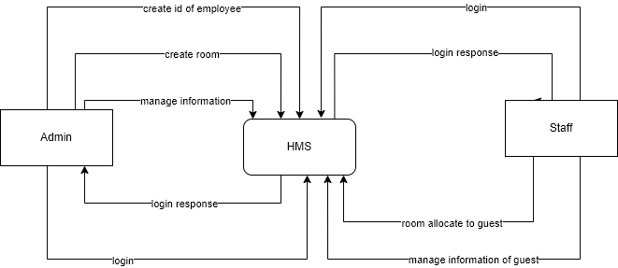

**Figure 0‑6Level 0 DFD for Hotel Mangement System**

**Level 1 DFD:**

In level 1 DFD, there are six processes where, process 1 is responsible, for admin login, and process 2 is responsible for creating the id for employees like staff, drivers, and other employees. Similarly, process 3 is responsible for staff login, and processes 4 and 5 are responsible for allocating the room and contacting the driver respectively. There are two entities and there are five data stores used in this level of DFD.

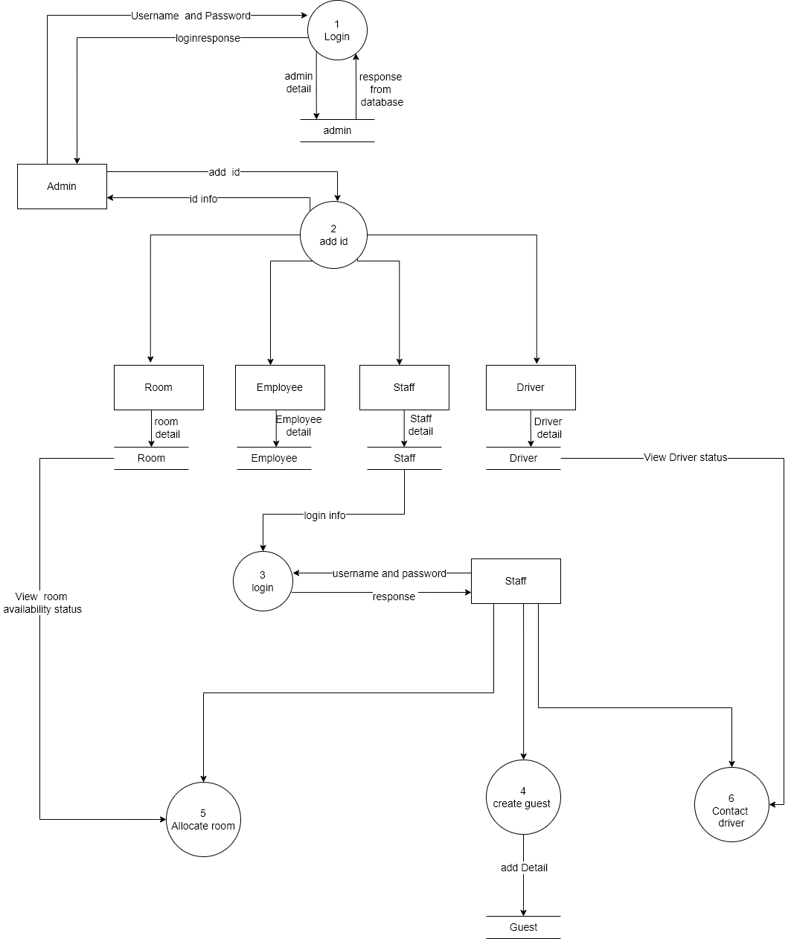

**Figure 0‑7 Level 1 DFD for Hotel Management System**

## **3.2. System Design**

To realize the different functional requirement of the system in graphical form, different design diagram of the system has been prepared which are as follows:

### 3.2.1. Architectural Design

As an Admin and Staff sign up directly via username and password, system databases collected the information of the Admin and Staff which gives access to software to the admin and Staff then. As shown in the figure when admin can perform tasks like creating the room, creating the staff driver and employee id, and viewing the detail of the employee, staff, driver, and room whenever required. When those creating tasks are completed they will save in their respective database.

Similarly, when the Admin creates the id for staff, they use that id to login into the system and perform the task like allocating the room, solving the queries of staff, contacting the driver, and viewing and managing the information of guests. they can also perform the checkout whenever required.

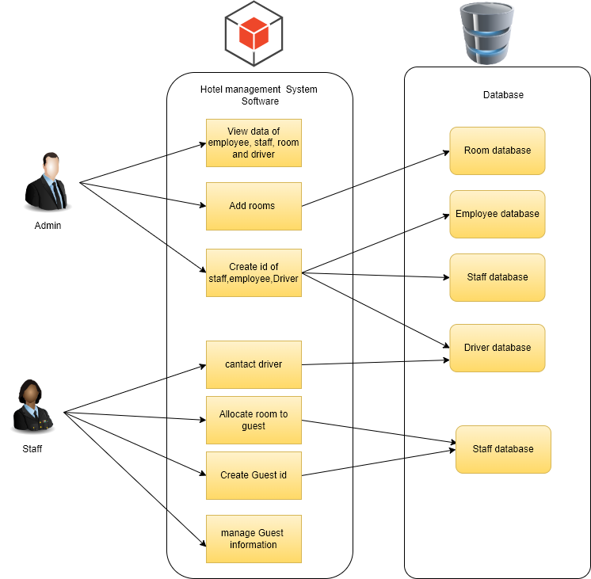

**Figure 0‑8 Architectural design**

### 3.2.2 System Flowchart

The figure below is the flowchart of the Hotel Management System for users. Here, the admin logs in to the system. After login success, then add details of room employee driver and staff and create id for them. When the admin creates an id for staff by using the same id staff login into the system and perform tasks like room allocation, managing the guest information, contacting the driver if the guest needs a driver, and checkout service.

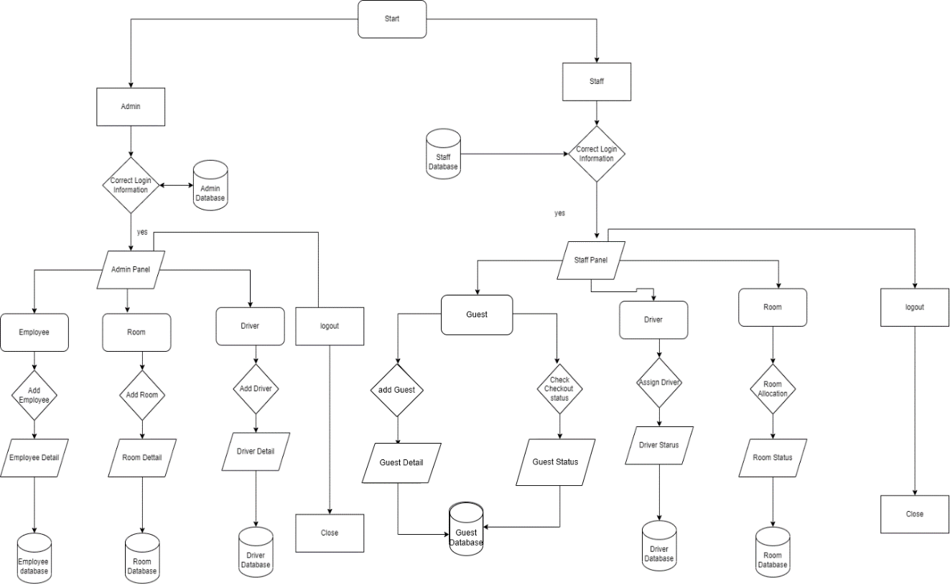

**Figure 0‑9 Flow chart of Hotel Management System**

### 3.2.3. Database Schema Design

The figure below is the database schema design of the Hotel Management system. Database schema design is used to show the basic structure of the system. In this system, there are six tables in the databases as admin, Staff, Driver Employee, Room, and Guest, and each of them have its fields.

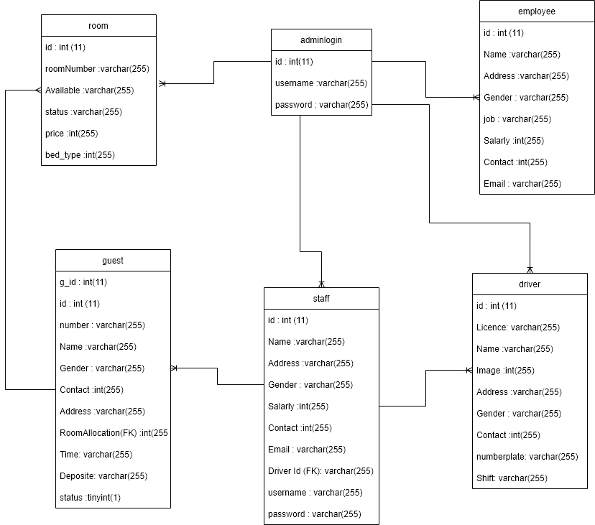

**Figure 0‑10 Database Schema design for Hotel Management System**

* Users (Admin) can create Staff Id, Driver Id, Employee id, and Room Id.
* Users can also monitor the Staff, Employees, and Drivers. If the admin needs anybody's information he/she can easily retrieve the data. Admin can also delete the information if the information is not further required.
* Staff can create many guests.
* Staff can also monitor the guest's information. This helps Staff during checkout time.
* A Staff can directly contact the Driver if the guest needs a driver.

### 3.2.4. Interface Design (UI Interface / Interface Structure Diagrams)

Interface design is used to design how the Hotel Management system looks and this design is shown the user how the system will look. And after finalizing the system development starts. The Figma design of the home page, register page, login page and dashboard, and contact and alert page of the medical emergency alert system are shown below:

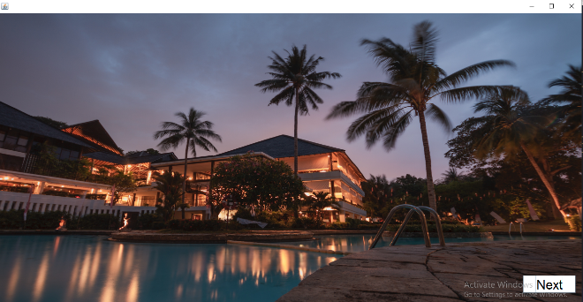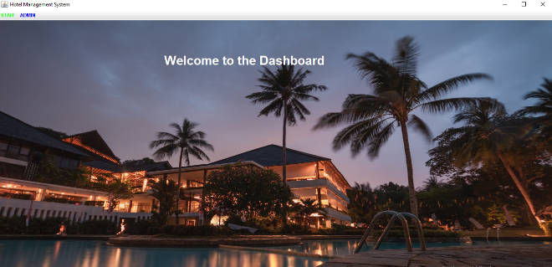Splash Screen Main page

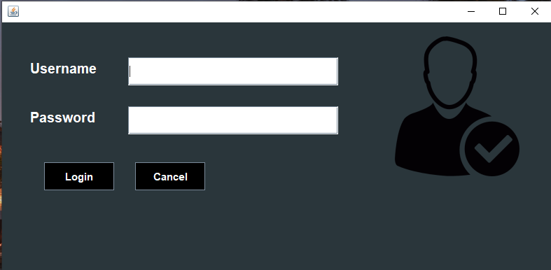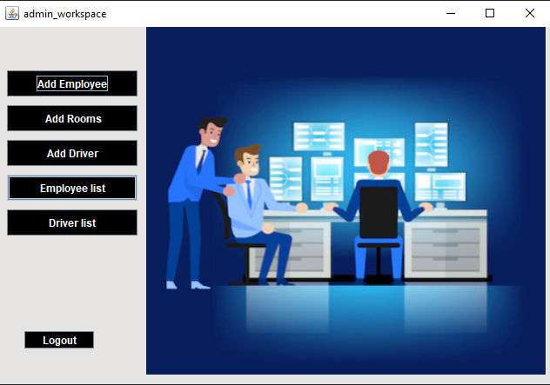 Admin login Admin dashboard

Employee added Room add

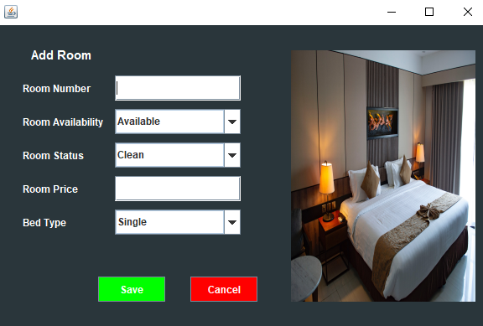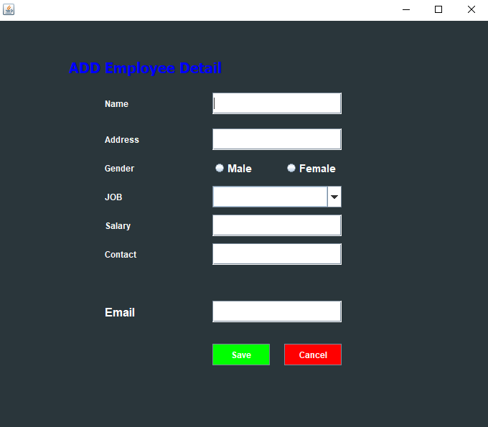

Driver add Staff login

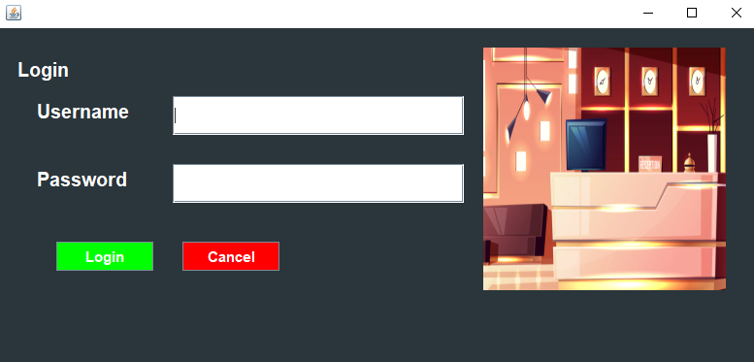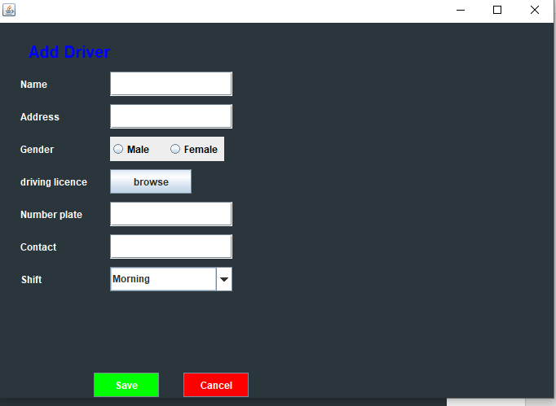

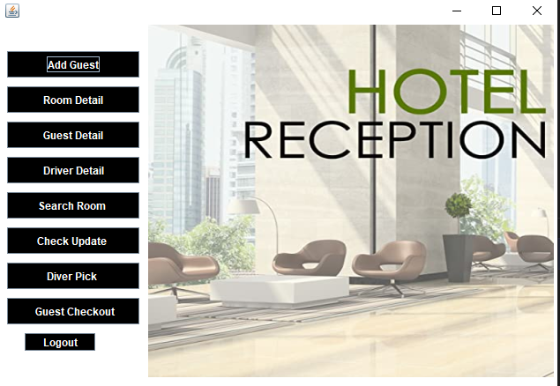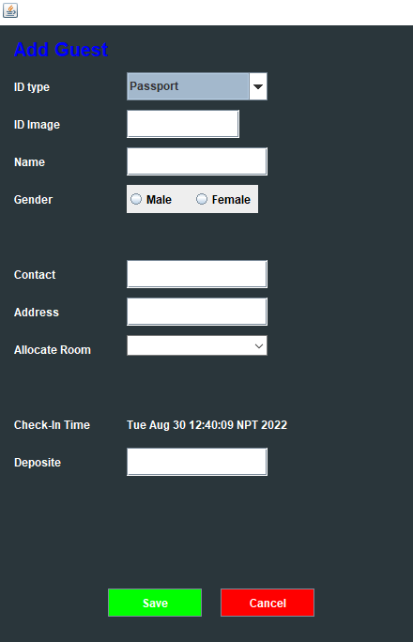Staff dashboard Guest add

Room searching

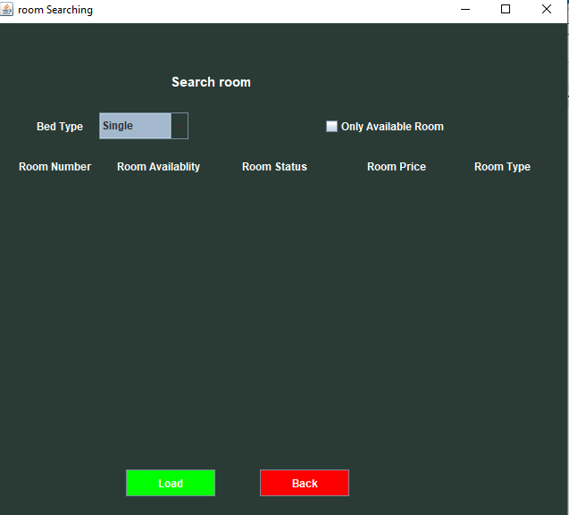

### 3.2.5. Physical DFD

Here, the admin login to the system, if it is successful then the admin adds the employee's id to the database, then staff logs into the system creates guest data, and stores it in the database.

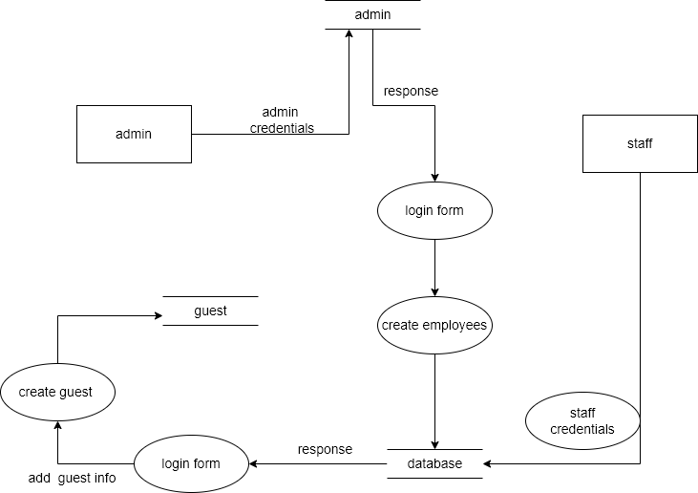

**Figure 0‑11Physical DFD of Hotel Management System**

## 3.3 Algorithm details

The system Hotel Management System uses one algorithm i.e. Linear Regression. Predicting future room occupancy for a hotel is one of the most important aspects of strategic planning. I wanted to analyze how internal and external factors of hotel can affect their booking in the future. This module contains complete analysis of data, includes time series analysis, confirms booking types of room prediction with the help of simple linear regression. Hence, linear regression algorithm is used to forecasting the future bed_type booking in my project.

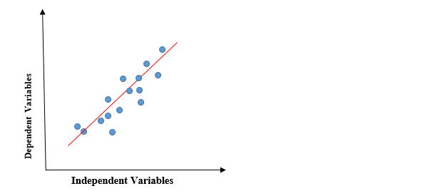

Whereas,

Y = dependent variable

x= independent variable

m=slope of the line

c= coefficient of the line

The simplest form of a simple linear regression equation with one dependent and one independent variable which is represented above:

For simplicity, let’s consider a sample dataset with 5 row and find out how to draw the regression line. Here Independent variable is no of occupency and Dependent variabale is the bed types in my project

|  |  |
| --- | --- |
| Independent variable | Dependent variable |
| X | **Y** |
| 1 | 2 |
| 2 | 4 |
| 3 | 5 |
| 4 | 4 |
| 5 | 5 |

**Tracing:**

|  |  |  |  |  |
| --- | --- | --- | --- | --- |
| **X** | **Y** | **X2** | **Y2** | **X*Y** |
| 1 | 2 | 1 | 4 | 2 |
| 2 | 4 | 4 | 16 | 8 |
| 3 | 5 | 9 | 25 | 15 |
| 4 | 4 | 16 | 16 | 16 |
| 5 | 5 | 25 | 25 | 25 |
| $\sum{x}=$ 15 | $\sum{y}=$ 20 | $\sum{x}2=$ 55 | $\sum{y2=}$ 86 | $\sum{x*y=}$ 66 |

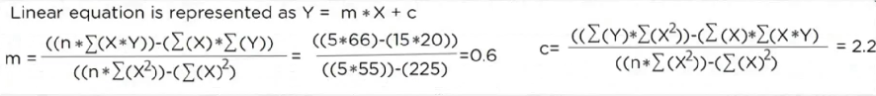

|  |
| --- |
| **Ppredicted**  Y =0.6*1+2.2 =2.8  Y =0.6*2+2.2 =3.4  Y =0.6*3+2.2 =4  Y =0.6*4+2.2 =4.6 |

|  |  |  |  |  |
| --- | --- | --- | --- | --- |
| **X** | **Y** | **Y** | **Y-Ypredict** | **(Y-Ypredict)2** |
| 1 | 2 | 2.8 | -0.8 | 0.64 |
| 2 | 4 | 3.4 | 0.6 | 0.36 |
| 3 | 5 | 4 | 1 | 1 |
| 4 | 4 | 4.6 | -0.6 | 0.36 |
| 5 | 5 | 5.2 | -0.2 | 0.04 |
|  |  |  |  | $\sum{(Y-Ypredict)2=}$ 2.4 |

Y =0.6*5+2.2 =5.2



Here blue points represent the actual Y value and the straight dotted line represent the predicted Y value.

The distance between the actual and predicted values are known as residual error.

The best fit line should have the least sum of square of these errors also known as e square.

# 

# IMPLEMENTATION AND TESTING

## **4.1. Implementation**

### 4.1.1. Tools Used (CASE tools, Programming language, Database platforms)

Following are the tools and framework used for the accomplishment of this project:

* **Java**

In the Hotel Management system, the java programming language is used in both the front end and back end. One of the concepts of core java i.e. Java swing is used to build this system.

* **MS Office**

This is used for writing and editing the documentation of the Hotel Management system.

* **Draw.io**

This is used to generate diagrams for system analysis and design of HMS. Diagrams were created using this tool to save time since all components are available with drag and drop functions.

* **MYSQL**

MySQL is an open-source relational database management system (RDBMS). We have used MySQL to store and retrieve data.

### 4.1.2. Implementation details of modules

Different modules of this system are described below:

**Admin Module**

* **Admin Login**

In this module, log into the system by entering a valid username and password. After login success, he/she has to add the details of Staff, Employees, Drivers, and rooms and store them in the database.

* **Employee, Staff, Driver, and Room Detail add/edit/delete**
* In this module, the admin can add, list, update and delete the detail of Employees, Staff, drivers, and Rooms in this existing system. The admin starts the action add by clicking on add button. Admin can also edit and delete existing data whenever required.
* **View List of Employee Staff Driver and Room**

Admin can view all the list of information related to Employee Staff Driver and Room whenever required.

**Staff Module**

* **Staff Login**

In this module, log into the system by entering a valid username and password. After login success, he/she has to add the details of the Guest and store them in the database.

* **Guest Add**

When Staff logs into his/her system he/she will be able to add Guest information .information like name, address contact, and other various details collected from guests, and add the detail into the database.

* **Room Allocation**

After collecting the information Staff allocated a room to the Guest according to their need. One Guest can take multiple rooms.

* **Contact Driver**

Whenever the Guest needs Driver, they contact the front office then the front –desk staff provides Driver to the Guest as soon as possible. Staff contact driver through call only.

* **View list of Guest**

Staff can view the detail of the Guest during checkout time. He/she will calculate the remaining payment by viewing the detail of the Guest.

## **4.2 Testing**

System testing is done by giving different training and testing datasets. This test is done to evaluate whether the system is providing an accurate summary or not. During the phase of the development of the system, our system is tested time and again. The series of testing conducted are as follow:

### 4.2.1 Test Cases for Unit Testing

In unit testing, we designed the entire system in a modularized pattern and each module is tested. Until we get the accurate output from the individual module, we work on the same module. The input forms are tested so that they do not accept invalid input.

**Admin Login**

**Table 0‑1 A test case for admin login in HMS.**

|  |  |  |  |  |  |
| --- | --- | --- | --- | --- | --- |
| S.No. | Test Name | Input | Expected  Output | Actual Output | Test Result |
| 1. | Enter username and password | Username = Manishh123  Password = abcde | Login failed | Login  Failed | Pass |
| 2. | Enter username and password | Username = manish  Password = 12345 | login successful | Redirect to Dashboard | Pass |

**Add Room**

**Table 0‑2 A test case for Add room HMS.**

|  |  |  |  |  |  |
| --- | --- | --- | --- | --- | --- |
| S.No. | Test Name | Input | Expected Output | Actual Output | Test Result |
| 1. | Room Number, Room Availability, Room Status, Room Price, Bed Type | Room Number:1000  Room Availability: Available  Room Status: Clean  Room Price: 2000  Bed_type: Single | Room Number already exists | Room Number already exists | Pass |
| 2. | Room Number, Room Availability, Room Status, Room Price, Bed Type | Room Number:1010  Room Availability: Available  Room Status: Clean  Room Price:  Bed_type: Single | Please enter Price | Please enter Price | Pass |
| 3 | Room Number, Room Availability, Room Status, Room Price, Bed Type | Room Number:1010  Room Availability: Available  Room Status: Clean  Room Price:3000  Bed_type: Single | Room added Successfully | Room added Successfully | Pass |

**Add Staff**

**Table 0‑3 A test case for Add room HMS.**

|  |  |  |  |  |  |
| --- | --- | --- | --- | --- | --- |
| S.No. | Test Name | Input | Expected Output | Actual Output | Test Result |
| 1. | Name, Address, Gender, Salary, Contact, Email, Username, Password | Name: Ram Thapa  Address: Nepaltar  Gender: Male  Salarly:50000  Contact:98494994949 Email:Ram@ gmail.com  Username:Ram123 Password:12345 | Please enter a valid number | Please enter a valid number | Pass |
| 2. | Name, Address, Gender, Salary, Contact, Email, Username, Password | Name: Ram Thapa  Address: Nepaltar  Gender: Male  Salarly:50000  Contact:9849499494 Email:Ramgmailcom  Username:Ram123 Password:12345 | Please enter a valid email | Please enter a valid email | Pass |
| 3 | Name, Address, Gender, Salary, Contact, Email, Username, Password | Name:  Address: Nepaltar  Gender: Male  Salarly:50000  Contact:9849499494 Email:Ram@gmail.com  Username:Ram123 Password:12345 | Please Enter Name | Please Enter Name | Pass |
| 4 | Name, Address, Gender, Salary, Contact, Email, Username, Password | Name: Ram Thapa  Address: Nepaltar  Gender: Male  Salarly:50000  Contact:9849499494 Email:Ram@gmail.com  Username:Ram123 Password:12345 | Staff added successfully | Staff added successfully | Pass |

**Add Employee**

**Table 0‑4 A test case for Add Employee in HMS.**

|  |  |  |  |  |  |
| --- | --- | --- | --- | --- | --- |
| S.No. | Test Name | Input | Expected Output | Actual Output | Test Result |
| 1. | Name, Address, Gender, Salary, Contact, Email, | Name: Shyam Thapa  Address: Nepaltar  Gender: Male  Salarly:50000  Contact:98494994949 Email: Shyam@ gmail.com | Please enter a valid number | Please enter a valid number | Pass |
| 2. | Name, Address, Gender, Salary, Contact, Email, | Name: Shyam Thapa  Address: Nepaltar  Gender: Male  Salarly:50000  Contact:9849499494 Email: Shyamgmailcom | Please enter a valid email | Please enter a valid email | Pass |
| 3 | Name, Address, Gender, Salary, Contact, Email, | Name:  Address: Nepaltar  Gender: Male  Salarly:50000  Contact:9849499494 Email:Shyma@gmail.com | Please Enter Name | Please Enter Name | Pass |
| 4 | Name, Address, Gender, Salary, Contact, Email, | Name: Ram Thapa  Address: Nepaltar  Gender: Male  Salarly:50000  Contact:9849499494 Email:Ram@gmail.com | Staff added successfully | Staff added successfully | Pass |

**Add Driver**

**Table 0‑5 A test case for Add Driver in HMS.**

|  |  |  |  |  |  |
| --- | --- | --- | --- | --- | --- |
| S.No. | Test Name | Input | Expected Output | Actual Output | Test Result |
| 1. | Name, Address, Gender, Image,  Contact,Salary,Shift | Name: Gopal Thapa  Address: Nepaltar  Gender: Male  Image:abc.jpg  Contact:98494994949  Salarly:40000  Shift: Morning | Please enter a valid number | Please enter a valid number | Pass |
| 2. | Name, Address, Gender, Image,  Contact,,Salary,Shift | Name: Gopal Thapa  Address: Nepaltar  Gender: Male  Image:  Contact:9845454545  Salarly:40000  Shift: Morning | Please enter image | Please enter image | Pass |
| 3 | Name, Address, Gender, Image,  Contact,,Salary,Shift | Name: Gopal Thapa  Address: Nepaltar  Gender: Male  Image:abc.jpg  Contact:9845454545  Salary:  Shift: Morning | Please enter salary | Please Enter salary | Pass |
| 4 | Name, Address, Gender, Image,  Contact,Salary,Shift | Name: Gopal Thapa  Address: Nepaltar  Gender: Male  Image:abc.jpg  Contact:9845454545  Salary: 30000  Shift: Morning | Driver added successfully | Driver added successfully | Pass |

**Staff Login**

**Table 0‑6 A test case for Staff login in HMS.**

|  |  |  |  |  |  |
| --- | --- | --- | --- | --- | --- |
| S.No. | Test Name | Input | Expected  Output | Actual Output | Test Result |
| 1. | Enter username and password | Username = Ram123  Password = abcde | Login failed | Login  Failed | Pass |
| 2. | Enter username and password | Username = Ram123  Password = 12345 | login successful | Redirect to Dashboard | Pass |

**Add Guest**

**Table 0‑7 A test case for Add Guest in HMS.**

|  |  |  |  |  |  |
| --- | --- | --- | --- | --- | --- |
| S.No. | Test Name | Input | Expected Output | Actual Output | Test Result |
| 1. | ID types, Identity,  Name, Gender,  Address, Contact, Checkin time, Deposite | ID types: Citizenship  Identity: abc.jpg  Name: Goma Thakur  Gender: Female  Address: gongbu  Contact:98605050503  Checkin time: Tue Aug 10 20:05 NPT 2022  Deposit: 500 | Please enter a valid number | Please enter a valid number | Pass |
| 2. | ID types, Identity,  Name, Gender,  Address, Contact, Checkin time, Deposite | ID types: Citizenship  Identity: abc.jpg  Name: Goma Thakur  Gender: Female  Address:  Contact:9860505050  Checkin time: Tue Aug 10 20:05 NPT 2022  Deposit: 500 | Please enter address | Please enter address | Pass |
| 3 | ID types, Identity,  Name, Gender,  Address, Contact, Checkin time, Deposite | ID types: Citizenship  Identity:  Name: Goma Thakur  Gender: Female  Address: gongabu  Contact:98605050503  Checkin time: Tue Aug 10 20:05 NPT 2022  Deposit: 500 | Please Enter image | Please Enter image | Pass |
| 4 | ID types, Identity,  Name, Gender,  Address, Contact, Checkin time, Deposite | ID types: Citizenship  Identity: abc.jpg  Name: Goma Thakur  Gender: Female  Address: gongabu  Contact:9860505050  Checkin time: Tue Aug 10 20:05 NPT 2022  Deposit: 500 | Guest added successfully | Guest added successfully | Pass |

# 

# CONCLUSION AND FUTURE RECOMMENDATIONS

## **5.1. Lesson Learnt / Outcome**

Every project makes us learn and gain knowledge in different aspects. In the following project, I learned lots of problem-solving skills and learned things about finding the solution on my own, proper use of guidelines, communication and writing skills, and management of the team.

* **Problem Solving Skills**

From this project, I have learned lots of problem-solving skills and also learned to recognize different errors that occur in this system and solve it.

* **Writing Skills**

I have learned how to prepare a proposal and documentation related to the project and also learned to use different case tools for use case diagram, schema diagram, data flow diagrams, and ER- diagram and so on.

* **Manage time**

The most important lesson learned was the management of time according to the complexity of the system components i.e. knowing which components to prioritize.

## **5.2 Conclusion**

In conclusion, we have done on describing every aspect of the topic in report writing so at last, we have developed a system i.e. android application which has been developed by android studio.

The project "Hotel Management System" was started to upgrade the working practice of the organization from a hardcopy base to a digital Desktop base platform. The main function of this system is to ease the working of the organization and organize, update, store, retrieve and report the necessary data and information for the future in a convenient way. It also helps the organization on wasting unnecessary time doing manual work for keeping and retrieving the records. It may be unusual for the first few times but it will be a much necessary system as the user gets used to it. While this system development there were many instances where we all felt like something more could be added but due to the lack of many elements, it will be updated and upgraded as they get used to this system in the upcoming days. By doing this project, we have been familiarized with practical knowledge of how Desktop applications are designed and developed. The essence of teamwork for the completion of the project has been realized and we have been built up with confidence regarding system analysis, designing, implementation, debugging, testing, and maintenance.

## **5.3 Future Recommendations**

The development project could have been more efficiently handled in design and development. The documentation process might have been better in programming the project before any documentation. In future work, the system will be upgraded having features like online reservation, and food ordering. Managing the bulk of data in a fraction of sec and many more.

* Apps for the driver so that they can update their record on their own.
* System for the employee who can able to take leave application whenever required.
* Apps/website for Guests to online reservations.
* In this project, data is stored in a local server so in the future it should be stored in cloud computing.

# REFERENCES

|  |  |
| --- | --- |
| [1] | "ezeefrontdesk," eZee FrontDesk, 2005-2022. [Online]. Available: https://www.ezeefrontdesk.com/. [Accessed 1 August 2022]. |
| [2] | hotelscombined, "hotelscombined," hotelscombined, 10 January 2022. [Online]. Available: https://www.hotelscombined.com/. [Accessed 05 August 2022]. |
| [3] | tutorialpoint, "https://www.ukessays.com/essays/information-technology/methodology-the-waterfall-model-information-technology-essay.php," UKEssays, 1st Jan 2015. [Online]. Available: https://www.ukessays.com/. [Accessed 05 August 2022]. |

# APENDICES

Splash Screen

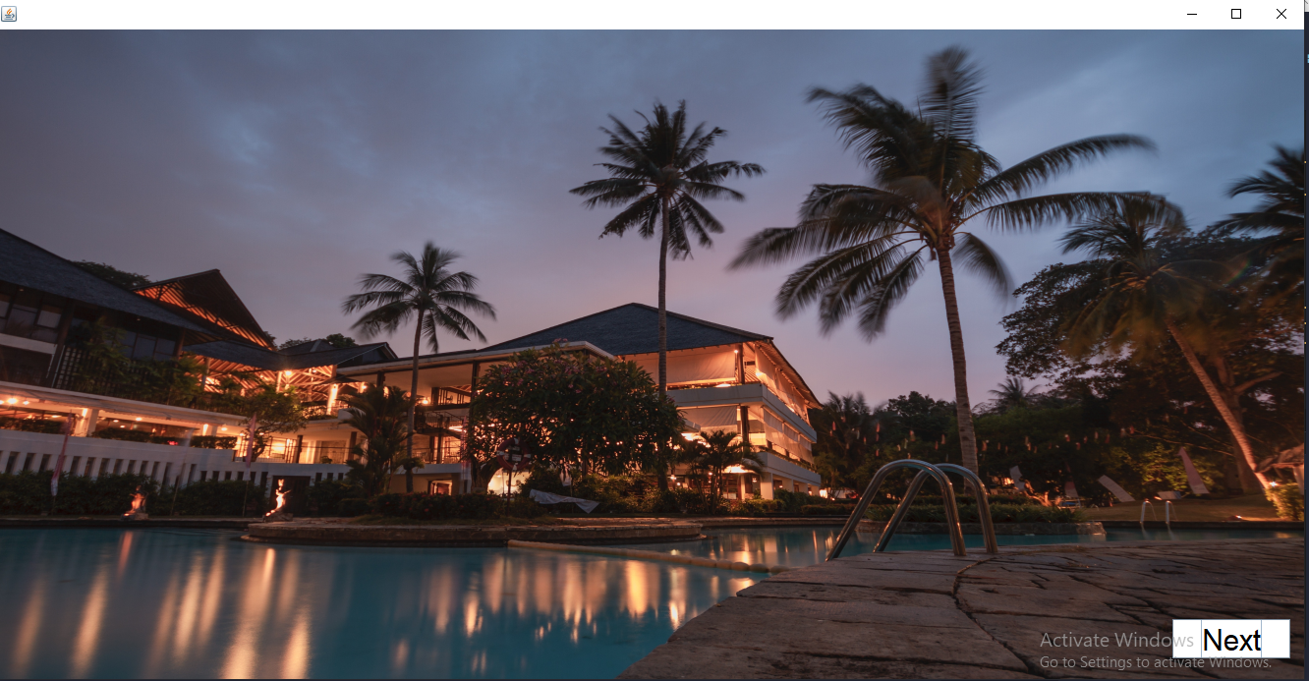

Home Page

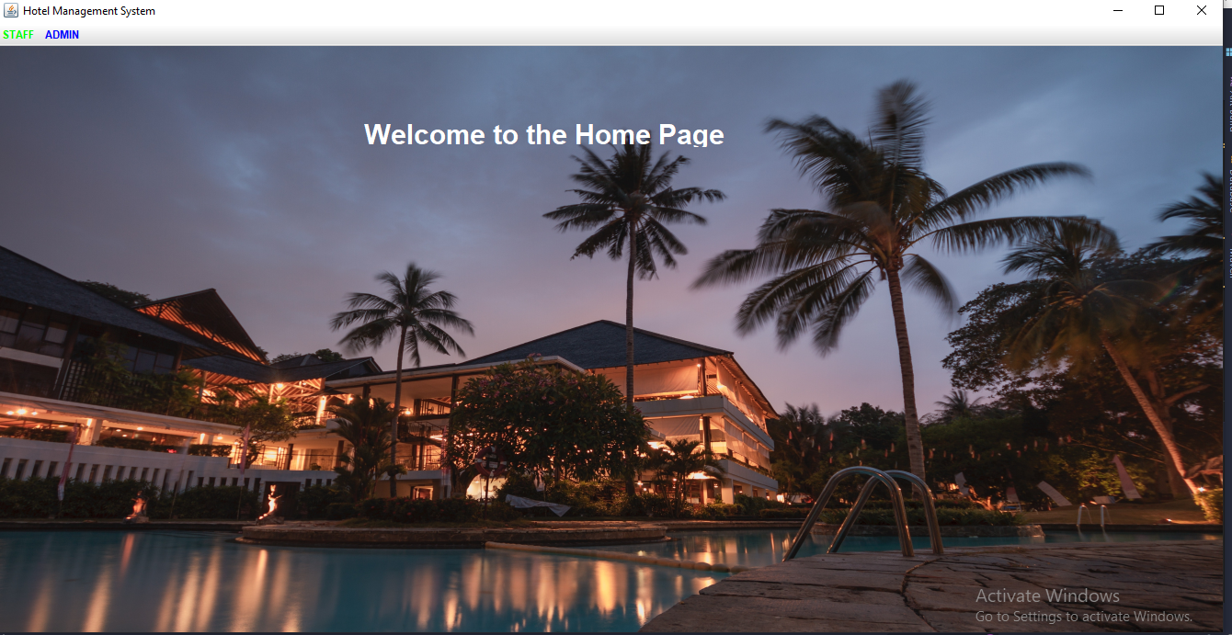

Admin Login

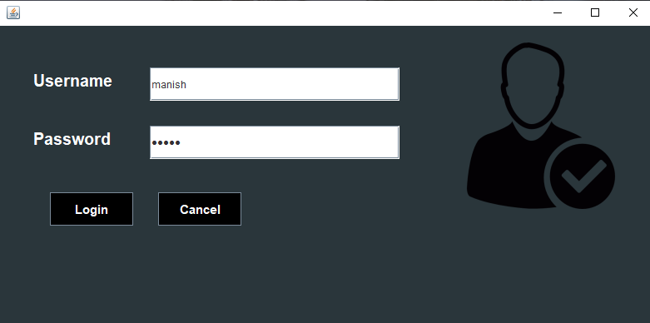

Admin Dashboard

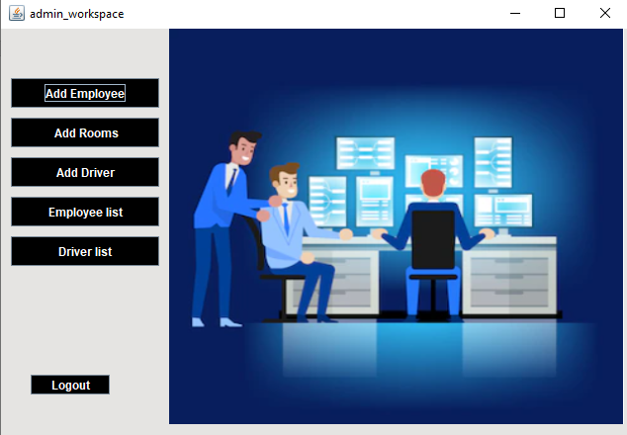

Add Employee

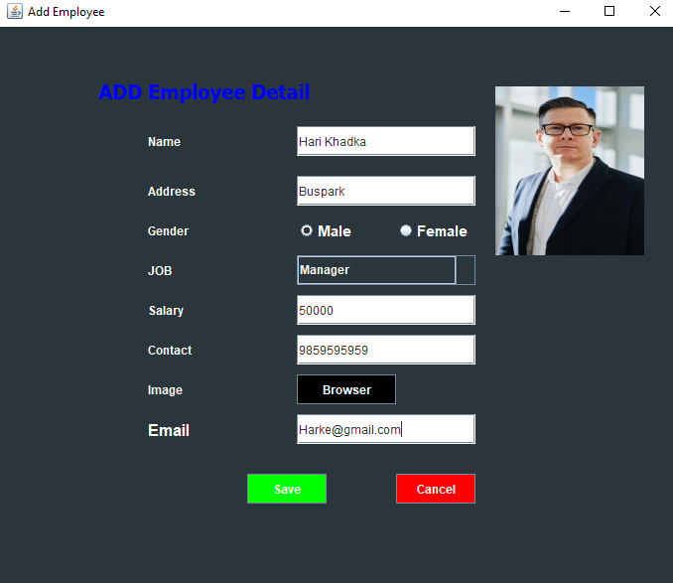

Add Room

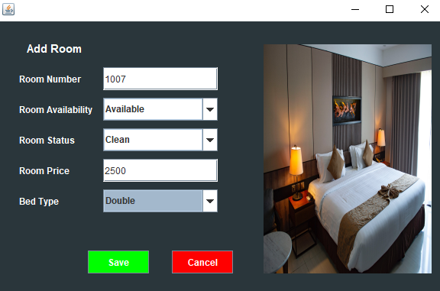

Add Driver

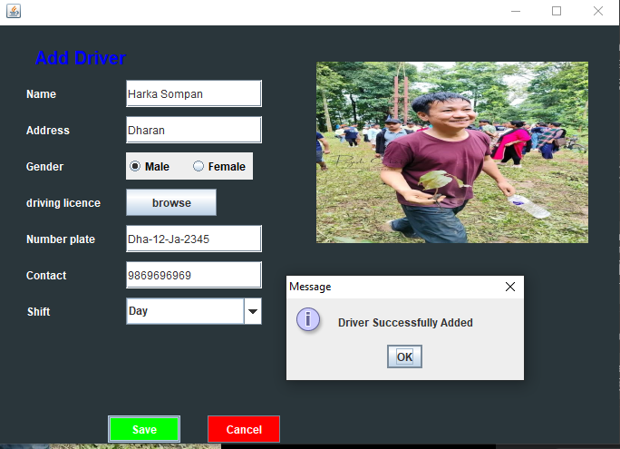

Employee list

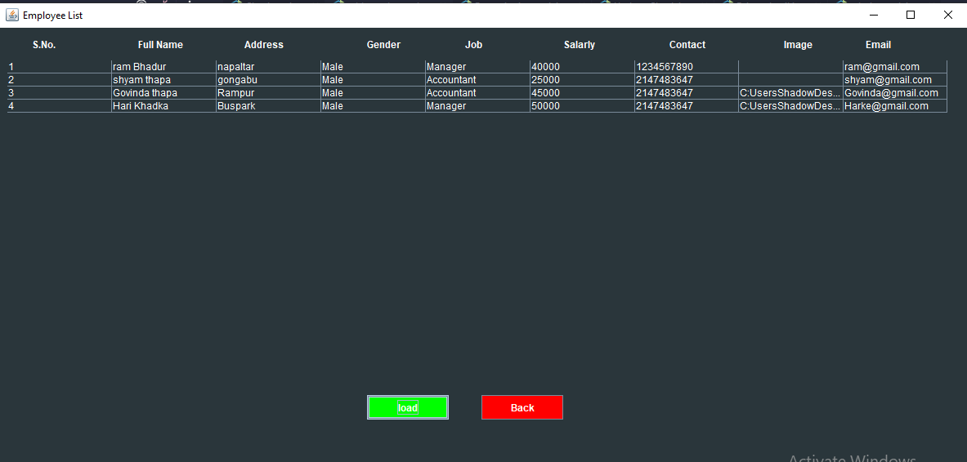

Driver List

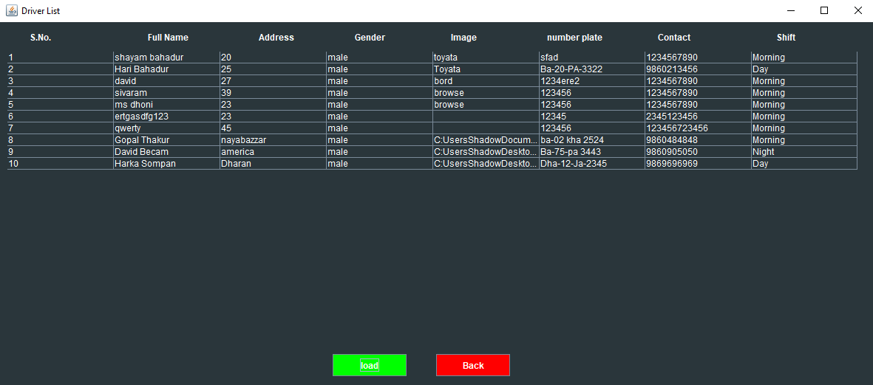

Staff Add

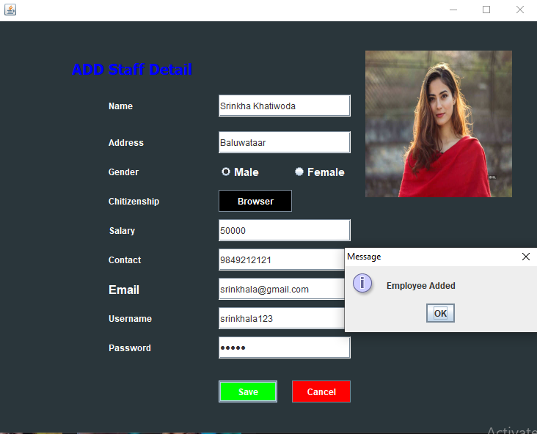

Staff List

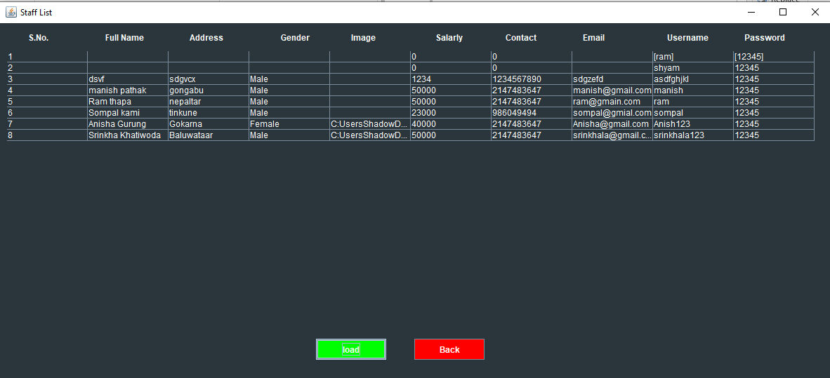

Staff Login

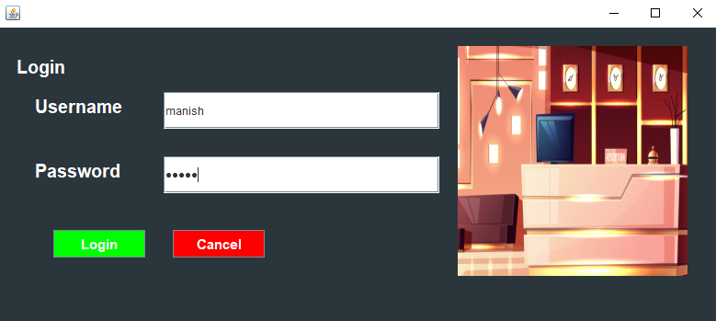

Guest Add

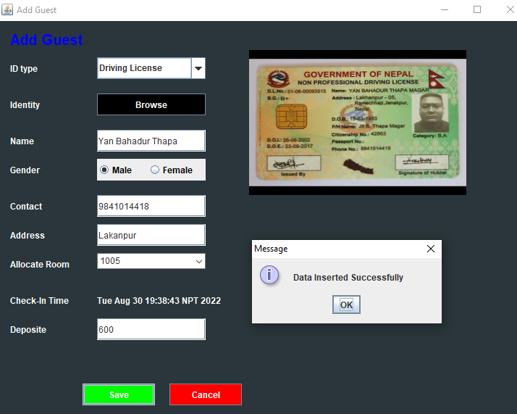

Guest Detail

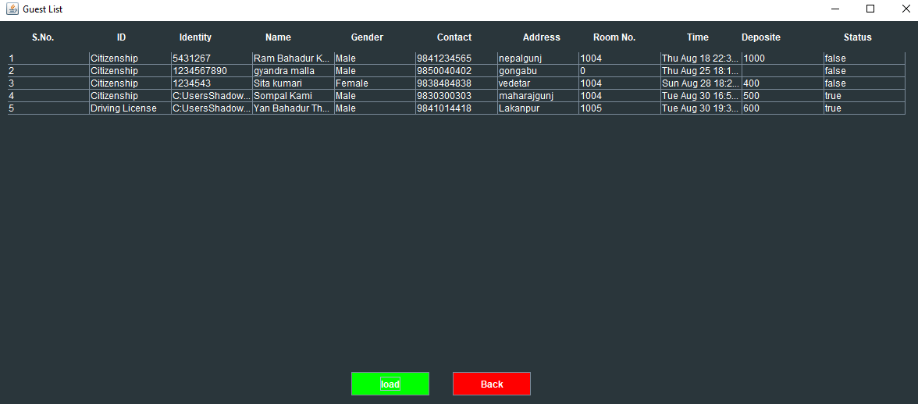

Search Room

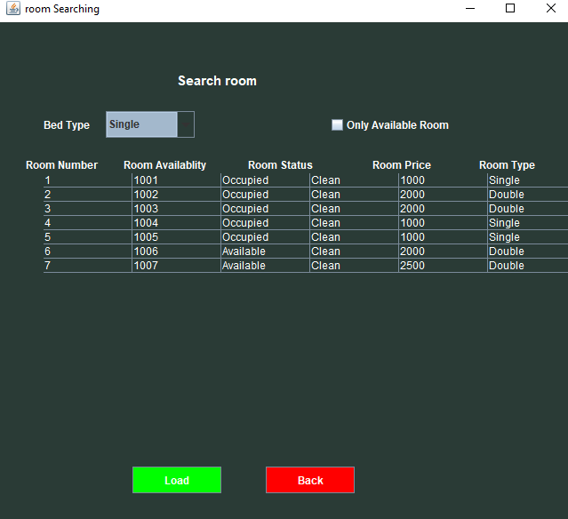

Update Guest Detail

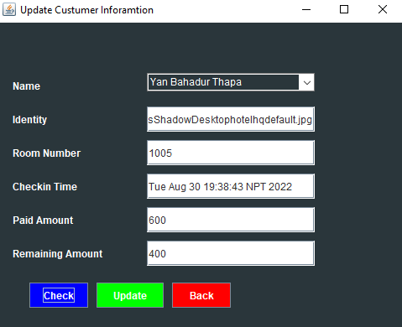

Guest Check Out

